AD: MELİSSA

SOYAD: İPEK

ÖĞRENCİ NO: 2012503043

BÖLÜM: YÖNETİM BİLİŞİM SİSTEMLERİ/3.SINIF A ŞUBESİ

**ORTA DÜZEY PROGRAMLAMA DÖNEM PROJESİ RAPORUM**

Merhabalar projemin ismi Diyetisyensayfasi olarak geçmektedir. Sitemin genel amacı kullanıcı giriş panelini içermektedir. Ve bu şekilde randevu sistemine giriş paneli açılmaktadır. Giriş ekranına hoşgeldiniz yazısı karşılamaktadır. Kullanıcı girişini çalıştırdığımızda ekranımızda şifre ve kullanıcı alanı olacaktır. Şifreyi göster kısmı da ekledim. Button kısmına tıkladığınızda giriş yapabileceksiniz. Kullanıcı adı ve şifre kısmı değişken olarak verilmiştir. Eğer boş veri veya tanımlanmayan veri gönderilirse kullanıcı adı ve şifresi hata verecektir. Button action kısmında tanımladığımız string ifade olan kullanıcı adı “Melissa” olan şifresi de “12345” veriler tanımladım. Bunları elbette arttırabiliriz. Bu string ifadeleri uygun yere yerleştirip giriş yaparsak yeni sayfada randevu ekranı açılacaktır. Bu sayfa kimlik numarası, ad, soyadı, telefon numarası, doktor, muayene saatlerinden oluşmaktadır. Kolaylık sağlamak için 2 tane combobox tanımladım. 3 tane değişken olan textfield alanımız mevcut. Zorunlu alan olduğunu belirten yıldızlar ve label ile destekledim. Randevu al kısmına basınca size mesaj ekranı vererek randevunuzu oluşturacaktır. Bunu option pane ekleyerek yaptım. Ekrana bu mesajı vermek için metot atamaları gerçekleştirdim. Daha sonrasında giriş ekranına tekrar gelirsek 2 tane buton oluşturarak burada giriş yapmadan vücut kitle indeksini ve size hazırlanan 1 haftalık diyet listesine ulaşabileceksiniz. Vücut kitle indeksine geldiğinizde boy ve kilonuzu girebileceğiniz alan mevcuttur. Hesapla butonuna tıklayınca size vücut kitle indeksinizi verecektir. Ayriyetten temizle butonu ekleyerek ekranı temizleyecektir. Amacımız genel olarak ufak bir diyetisyen randevu otomasyonu oluşturmaktır. Paneller arası geçişimi sağlayan örnek kodu şu şekilde tanımlıyorum;

diyetlistesi frame= new diyetlistesi();

frame.setVisible(true);

this.setVisible(false);

Bu şekilde panelden panele button ile geçiş sağlıyorum. Setvisible ile de ekran panel karşına çıksın mı çıkmasın mı olarak 2 değer ataması yapıyoruz. (True veya False)

Randevu ekranında metot atamak için string bir mesaj tanımlayıp sonra bunun içine atama yaptık. Textler için get.Text, combobox için SelectedItem kullandım. Option pane kullanarak da mesaj ekranı verdim. Aşağıdaki gibi kod bloğunu inceleyebilirsiniz;

String mesaj=String.format("Kimlik Numarası: %s \nAd Soyad: %s \nTelefon No: %s \nDoktor: %s \nMuayene Saati: %s saatine randevunuz başarıyla oluşturulmuştur.",kimliknumarası.getText(),adsoyad.getText(),telefonno.getText(),doktorlar.getSelectedItem(),muayenesaati.getSelectedItem());

jOptionPane1.showMessageDialog(null, mesaj);

Genel olarak nesnesel tabanlı, swing kullanarak bir proje hazırladım. Projemde componentler mevcut, this kullanımı da vardır. Metotları anlamlı şekilde birbirleriyle uyumlu kullanmaya çalıştım. Private olarak değişkenlerimi çalışmaya çalıştım. Genel olarak bu şekilde bir proje oluşturdum.

🡪GİRİŞ EKRANI:

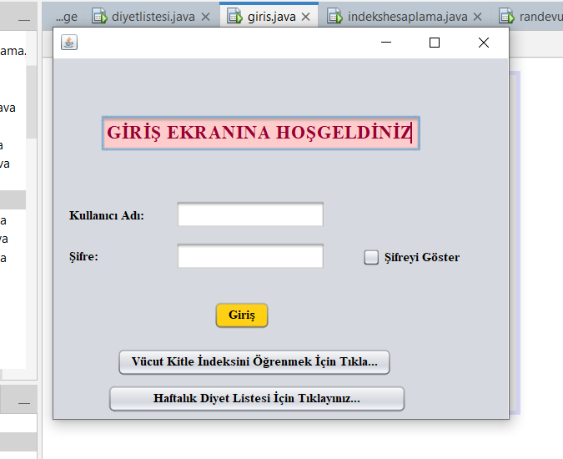

🡪GİRİŞ BAŞARILI: 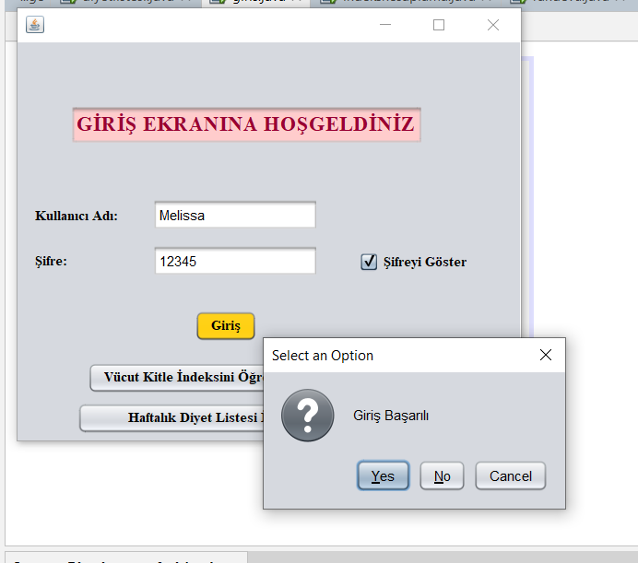

🡪GİRİŞ BAŞARISIZ:

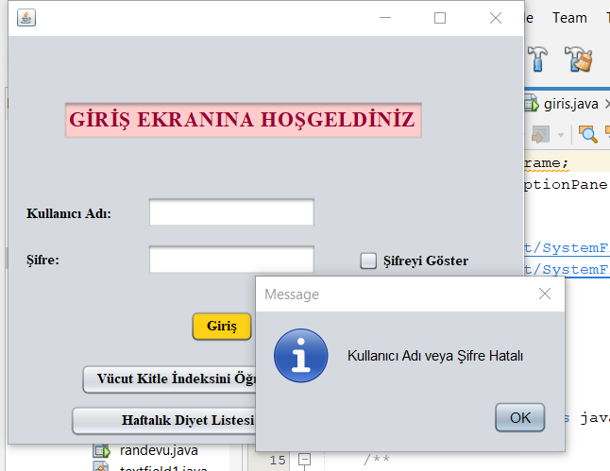

🡪RANDEVU EKRANI:

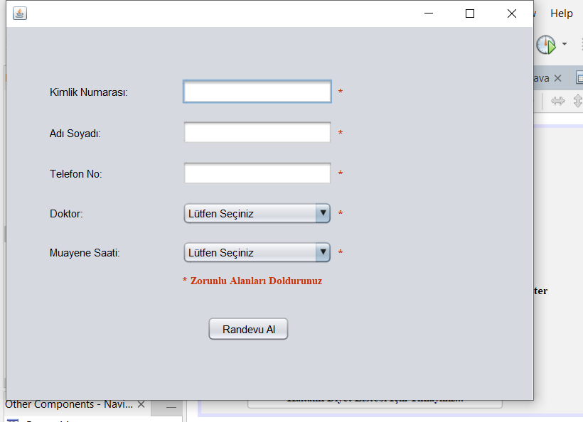

🡪RANDEVU OLUŞTURMA MESAJI:

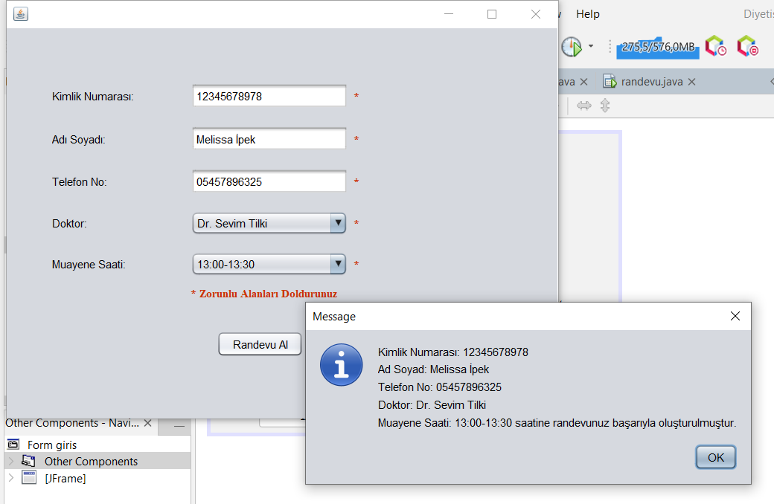

🡪DİYET LİSTESİ EKRANI:

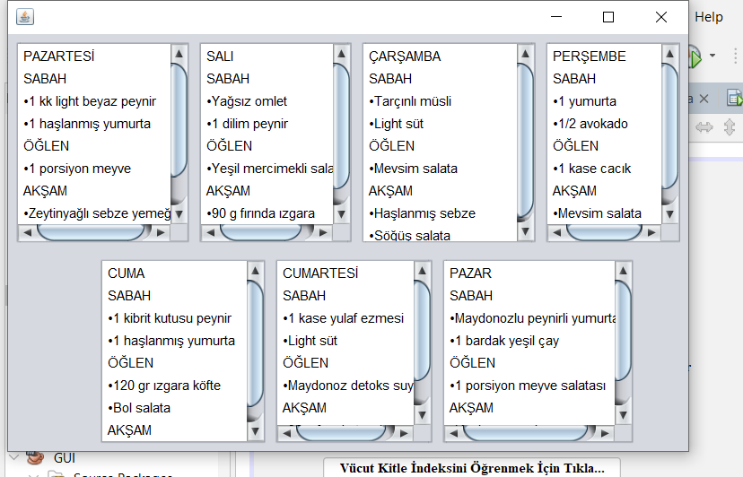

🡪VÜCUT KİTLE İNDEKSİ EKRANI:

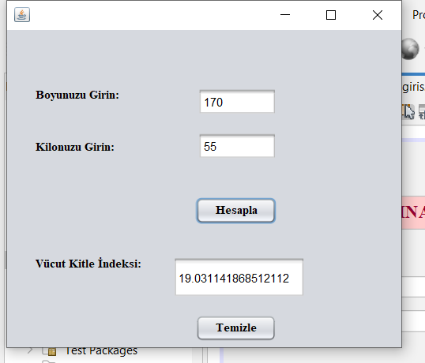

**DİYETİSYEN SAYFAMIN KODLARI**

🡪 kullanıcıgirisi.java form sayfam

/*

* Click nbfs://nbhost/SystemFileSystem/Templates/Licenses/license-default.txt to change this license

* Click nbfs://nbhost/SystemFileSystem/Templates/Classes/Main.java to edit this template

*/

package kullanicigirisi;

/**

*

* @author victus

*/

public class Kullanicigirisi {

/**

* @param args the command line arguments

*/

public static void main(String[] args) {

// TODO code application logic here

}

}

🡪 giris.java form sayfam

import javax.swing.JFrame;

import javax.swing.JOptionPane;

/*

* Click nbfs://nbhost/SystemFileSystem/Templates/Licenses/license-default.txt to change this license

* Click nbfs://nbhost/SystemFileSystem/Templates/GUIForms/JFrame.java to edit this template

*/

/**

*

* @author victus

*/

public class giris extends javax.swing.JFrame {

/**

* Creates new form giris

*/

public giris() {

initComponents();

}

/**

* This method is called from within the constructor to initialize the form.

* WARNING: Do NOT modify this code. The content of this method is always

* regenerated by the Form Editor.

*/

@SuppressWarnings("unchecked")

// <editor-fold defaultstate="collapsed" desc="Generated Code">

private void initComponents() {

jLabel1 = new javax.swing.JLabel();

jLabel2 = new javax.swing.JLabel();

jCheckBox1 = new javax.swing.JCheckBox();

jtex_kad = new javax.swing.JTextField();

button_giris = new javax.swing.JButton();

jpass = new javax.swing.JPasswordField();

jTextField1 = new javax.swing.JTextField();

button_liste = new javax.swing.JButton();

button_indeks = new javax.swing.JButton();

setDefaultCloseOperation(javax.swing.WindowConstants.EXIT_ON_CLOSE);

jLabel1.setFont(new java.awt.Font("Times New Roman", 1, 12)); // NOI18N

jLabel1.setText("Kullanıcı Adı:");

jLabel2.setFont(new java.awt.Font("Times New Roman", 1, 12)); // NOI18N

jLabel2.setText("Şifre:");

jCheckBox1.setFont(new java.awt.Font("Times New Roman", 1, 12)); // NOI18N

jCheckBox1.setText("Şifreyi Göster");

jCheckBox1.addActionListener(new java.awt.event.ActionListener() {

public void actionPerformed(java.awt.event.ActionEvent evt) {

jCheckBox1ActionPerformed(evt);

}

});

jtex_kad.addActionListener(new java.awt.event.ActionListener() {

public void actionPerformed(java.awt.event.ActionEvent evt) {

jtex_kadActionPerformed(evt);

}

});

button_giris.setBackground(new java.awt.Color(255, 204, 0));

button_giris.setFont(new java.awt.Font("Times New Roman", 1, 12)); // NOI18N

button_giris.setText("Giriş");

button_giris.addActionListener(new java.awt.event.ActionListener() {

public void actionPerformed(java.awt.event.ActionEvent evt) {

button_girisActionPerformed(evt);

}

});

jpass.addActionListener(new java.awt.event.ActionListener() {

public void actionPerformed(java.awt.event.ActionEvent evt) {

jpassActionPerformed(evt);

}

});

jTextField1.setBackground(new java.awt.Color(255, 204, 204));

jTextField1.setFont(new java.awt.Font("Times New Roman", 1, 18)); // NOI18N

jTextField1.setForeground(new java.awt.Color(153, 0, 51));

jTextField1.setText("GİRİŞ EKRANINA HOŞGELDİNİZ");

jTextField1.addActionListener(new java.awt.event.ActionListener() {

public void actionPerformed(java.awt.event.ActionEvent evt) {

jTextField1ActionPerformed(evt);

}

});

button_liste.setFont(new java.awt.Font("Times New Roman", 1, 12)); // NOI18N

button_liste.setText("Haftalık Diyet Listesi İçin Tıklayınız...");

button_liste.addActionListener(new java.awt.event.ActionListener() {

public void actionPerformed(java.awt.event.ActionEvent evt) {

button_listeActionPerformed(evt);

}

});

button_indeks.setFont(new java.awt.Font("Times New Roman", 1, 12)); // NOI18N

button_indeks.setText("Vücut Kitle İndeksini Öğrenmek İçin Tıkla...");

button_indeks.addActionListener(new java.awt.event.ActionListener() {

public void actionPerformed(java.awt.event.ActionEvent evt) {

button_indeksActionPerformed(evt);

}

});

javax.swing.GroupLayout layout = new javax.swing.GroupLayout(getContentPane());

getContentPane().setLayout(layout);

layout.setHorizontalGroup(

layout.createParallelGroup(javax.swing.GroupLayout.Alignment.LEADING)

.addGroup(layout.createSequentialGroup()

.addGroup(layout.createParallelGroup(javax.swing.GroupLayout.Alignment.LEADING)

.addGroup(layout.createSequentialGroup()

.addGap(15, 15, 15)

.addGroup(layout.createParallelGroup(javax.swing.GroupLayout.Alignment.LEADING)

.addComponent(jLabel1, javax.swing.GroupLayout.PREFERRED_SIZE, 72, javax.swing.GroupLayout.PREFERRED_SIZE)

.addComponent(jLabel2))

.addGap(30, 30, 30)

.addGroup(layout.createParallelGroup(javax.swing.GroupLayout.Alignment.LEADING)

.addGroup(layout.createSequentialGroup()

.addComponent(jpass, javax.swing.GroupLayout.PREFERRED_SIZE, 144, javax.swing.GroupLayout.PREFERRED_SIZE)

.addGap(35, 35, 35)

.addComponent(jCheckBox1))

.addComponent(jtex_kad, javax.swing.GroupLayout.PREFERRED_SIZE, 144, javax.swing.GroupLayout.PREFERRED_SIZE)))

.addGroup(layout.createSequentialGroup()

.addGap(154, 154, 154)

.addComponent(button_giris))

.addGroup(layout.createSequentialGroup()

.addGap(61, 61, 61)

.addComponent(button_indeks))

.addGroup(layout.createSequentialGroup()

.addGap(52, 52, 52)

.addComponent(button_liste, javax.swing.GroupLayout.PREFERRED_SIZE, 287, javax.swing.GroupLayout.PREFERRED_SIZE))

.addGroup(layout.createSequentialGroup()

.addGap(46, 46, 46)

.addComponent(jTextField1, javax.swing.GroupLayout.PREFERRED_SIZE, javax.swing.GroupLayout.DEFAULT_SIZE, javax.swing.GroupLayout.PREFERRED_SIZE)))

.addContainerGap(47, Short.MAX_VALUE))

);

layout.setVerticalGroup(

layout.createParallelGroup(javax.swing.GroupLayout.Alignment.LEADING)

.addGroup(layout.createSequentialGroup()

.addGap(55, 55, 55)

.addComponent(jTextField1, javax.swing.GroupLayout.PREFERRED_SIZE, 34, javax.swing.GroupLayout.PREFERRED_SIZE)

.addGap(47, 47, 47)

.addGroup(layout.createParallelGroup(javax.swing.GroupLayout.Alignment.BASELINE)

.addComponent(jLabel1, javax.swing.GroupLayout.PREFERRED_SIZE, 22, javax.swing.GroupLayout.PREFERRED_SIZE)

.addComponent(jtex_kad))

.addPreferredGap(javax.swing.LayoutStyle.ComponentPlacement.UNRELATED)

.addGroup(layout.createParallelGroup(javax.swing.GroupLayout.Alignment.LEADING)

.addComponent(jLabel2, javax.swing.GroupLayout.Alignment.TRAILING, javax.swing.GroupLayout.DEFAULT_SIZE, 24, Short.MAX_VALUE)

.addGroup(layout.createParallelGroup(javax.swing.GroupLayout.Alignment.BASELINE)

.addComponent(jpass, javax.swing.GroupLayout.PREFERRED_SIZE, javax.swing.GroupLayout.DEFAULT_SIZE, javax.swing.GroupLayout.PREFERRED_SIZE)

.addComponent(jCheckBox1, javax.swing.GroupLayout.DEFAULT_SIZE, javax.swing.GroupLayout.DEFAULT_SIZE, Short.MAX_VALUE)))

.addGap(29, 29, 29)

.addComponent(button_giris)

.addGap(18, 18, 18)

.addComponent(button_indeks)

.addGap(8, 8, 8)

.addComponent(button_liste)

.addContainerGap())

);

pack();

}// </editor-fold>

private void jCheckBox1ActionPerformed(java.awt.event.ActionEvent evt) {

if (jCheckBox1.isSelected()) {

jpass.setEchoChar((char)0);

}

else {

jpass.setEchoChar('*');

}

}

private void jpassActionPerformed(java.awt.event.ActionEvent evt) {

// TODO add your handling code here:

}

private void button_girisActionPerformed(java.awt.event.ActionEvent evt) {

randevu frame= new randevu();

String k_ad = "Melissa";

String password = "12345";

if (jtex_kad.getText().equals(k_ad)&& jpass.getText().equals(password)) {

JOptionPane.showConfirmDialog(null, "Giriş Başarılı");

frame.setVisible(true);

this.setVisible(false);

}

else {

JOptionPane.showMessageDialog(null, "Kullanıcı Adı veya Şifre Hatalı");

jtex_kad.setText("");

jpass.setText("");

}

}

private void jTextField1ActionPerformed(java.awt.event.ActionEvent evt) {

// TODO add your handling code here:

}

private void button_listeActionPerformed(java.awt.event.ActionEvent evt) {

diyetlistesi frame= new diyetlistesi();

frame.setVisible(true);

this.setVisible(false);

}

private void jtex_kadActionPerformed(java.awt.event.ActionEvent evt) {

// TODO add your handling code here:

}

private void button_indeksActionPerformed(java.awt.event.ActionEvent evt) {

indekshesaplama frame= new indekshesaplama();

frame.setVisible(true);

this.setVisible(false);

}

/**

* @param args the command line arguments

*/

public static void main(String args[]) {

/* Set the Nimbus look and feel */

//<editor-fold defaultstate="collapsed" desc=" Look and feel setting code (optional) ">

/* If Nimbus (introduced in Java SE 6) is not available, stay with the default look and feel.

* For details see http://download.oracle.com/javase/tutorial/uiswing/lookandfeel/plaf.html

*/

try {

for (javax.swing.UIManager.LookAndFeelInfo info : javax.swing.UIManager.getInstalledLookAndFeels()) {

if ("Nimbus".equals(info.getName())) {

javax.swing.UIManager.setLookAndFeel(info.getClassName());

break;

}

}

} catch (ClassNotFoundException ex) {

java.util.logging.Logger.getLogger(giris.class.getName()).log(java.util.logging.Level.SEVERE, null, ex);

} catch (InstantiationException ex) {

java.util.logging.Logger.getLogger(giris.class.getName()).log(java.util.logging.Level.SEVERE, null, ex);

} catch (IllegalAccessException ex) {

java.util.logging.Logger.getLogger(giris.class.getName()).log(java.util.logging.Level.SEVERE, null, ex);

} catch (javax.swing.UnsupportedLookAndFeelException ex) {

java.util.logging.Logger.getLogger(giris.class.getName()).log(java.util.logging.Level.SEVERE, null, ex);

}

//</editor-fold>

/* Create and display the form */

java.awt.EventQueue.invokeLater(() -> {

new giris().setVisible(true);

});

}

// Variables declaration - do not modify

private javax.swing.JButton button_giris;

private javax.swing.JButton button_indeks;

private javax.swing.JButton button_liste;

private javax.swing.JCheckBox jCheckBox1;

private javax.swing.JLabel jLabel1;

private javax.swing.JLabel jLabel2;

private javax.swing.JTextField jTextField1;

private javax.swing.JPasswordField jpass;

private javax.swing.JTextField jtex_kad;

// End of variables declaration

private void setDefaultCloseOperation() {

throw new UnsupportedOperationException("Not supported yet."); // Generated from nbfs://nbhost/SystemFileSystem/Templates/Classes/Code/GeneratedMethodBody

}

}

🡪randevu.java form sayfam

import javax.swing.JFrame;

import javax.swing.JOptionPane;

/*

* Click nbfs://nbhost/SystemFileSystem/Templates/Licenses/license-default.txt to change this license

* Click nbfs://nbhost/SystemFileSystem/Templates/GUIForms/JFrame.java to edit this template

*/

/**

*

* @author victus

*/

public class randevu extends javax.swing.JFrame {

/**

* Creates new form randevu

*/

public randevu() {

initComponents();

}

/**

* This method is called from within the constructor to initialize the form.

* WARNING: Do NOT modify this code. The content of this method is always

* regenerated by the Form Editor.

*/

@SuppressWarnings("unchecked")

// <editor-fold defaultstate="collapsed" desc="Generated Code">

private void initComponents() {

jLabel1 = new javax.swing.JLabel();

jOptionPane1 = new javax.swing.JOptionPane();

kimlik_num = new javax.swing.JLabel();

ad_soyad = new javax.swing.JLabel();

doktor = new javax.swing.JLabel();

muayene_saati = new javax.swing.JLabel();

telefon_no = new javax.swing.JLabel();

kimliknumarası = new javax.swing.JTextField();

adsoyad = new javax.swing.JTextField();

telefonno = new javax.swing.JTextField();

doktorlar = new javax.swing.JComboBox<>();

button_randevu = new javax.swing.JButton();

muayenesaati = new javax.swing.JComboBox<>();

zorunlualan = new javax.swing.JLabel();

jLabel2 = new javax.swing.JLabel();

jLabel3 = new javax.swing.JLabel();

jLabel4 = new javax.swing.JLabel();

jLabel5 = new javax.swing.JLabel();

jLabel6 = new javax.swing.JLabel();

jLabel1.setText("jLabel1");

setDefaultCloseOperation(javax.swing.WindowConstants.EXIT_ON_CLOSE);

kimlik_num.setText("Kimlik Numarası:");

ad_soyad.setText("Adı Soyadı:");

doktor.setText("Doktor:");

muayene_saati.setText("Muayene Saati:");

telefon_no.setText("Telefon No:");

kimliknumarası.addMouseMotionListener(new java.awt.event.MouseMotionAdapter() {

public void mouseMoved(java.awt.event.MouseEvent evt) {

kimliknumarasıMouseMoved(evt);

}

});

kimliknumarası.addActionListener(new java.awt.event.ActionListener() {

public void actionPerformed(java.awt.event.ActionEvent evt) {

kimliknumarasıActionPerformed(evt);

}

});

telefonno.addActionListener(new java.awt.event.ActionListener() {

public void actionPerformed(java.awt.event.ActionEvent evt) {

telefonnoActionPerformed(evt);

}

});

doktorlar.setModel(new javax.swing.DefaultComboBoxModel<>(new String[] { "Lütfen Seçiniz", "Dr. Levent Kale", "Dr. Sevim Tilki", "Dr. Ayşe Kabasakal", "Dr. Erdem Torun", "Dr. Kadriye Kodaman", "Dr. Fahrettin Kağıt" }));

button_randevu.setText("Randevu Al");

button_randevu.addActionListener(new java.awt.event.ActionListener() {

public void actionPerformed(java.awt.event.ActionEvent evt) {

button_randevuActionPerformed(evt);

}

});

muayenesaati.setModel(new javax.swing.DefaultComboBoxModel<>(new String[] { "Lütfen Seçiniz", "09:00-09:30", "10:00-10:30", "11:00-11:30", "13:00-13:30", "14:00-14:30", "15:00-15:30", " ", " " }));

zorunlualan.setFont(new java.awt.Font("Times New Roman", 1, 12)); // NOI18N

zorunlualan.setForeground(new java.awt.Color(204, 51, 0));

zorunlualan.setText("*");

zorunlualan.addMouseMotionListener(new java.awt.event.MouseMotionAdapter() {

public void mouseMoved(java.awt.event.MouseEvent evt) {

zorunlualanMouseMoved(evt);

}

});

jLabel2.setFont(new java.awt.Font("Times New Roman", 1, 12)); // NOI18N

jLabel2.setForeground(new java.awt.Color(204, 51, 0));

jLabel2.setText("*");

jLabel3.setFont(new java.awt.Font("Times New Roman", 1, 12)); // NOI18N

jLabel3.setForeground(new java.awt.Color(204, 51, 0));

jLabel3.setText("*");

jLabel4.setFont(new java.awt.Font("Times New Roman", 1, 12)); // NOI18N

jLabel4.setForeground(new java.awt.Color(204, 51, 0));

jLabel4.setText("*");

jLabel5.setFont(new java.awt.Font("Times New Roman", 1, 12)); // NOI18N

jLabel5.setForeground(new java.awt.Color(204, 51, 0));

jLabel5.setText("*");

jLabel6.setFont(new java.awt.Font("Times New Roman", 1, 12)); // NOI18N

jLabel6.setForeground(new java.awt.Color(204, 51, 0));

jLabel6.setText("* Zorunlu Alanları Doldurunuz");

javax.swing.GroupLayout layout = new javax.swing.GroupLayout(getContentPane());

getContentPane().setLayout(layout);

layout.setHorizontalGroup(

layout.createParallelGroup(javax.swing.GroupLayout.Alignment.LEADING)

.addGroup(layout.createSequentialGroup()

.addGap(49, 49, 49)

.addGroup(layout.createParallelGroup(javax.swing.GroupLayout.Alignment.LEADING, false)

.addComponent(kimlik_num, javax.swing.GroupLayout.DEFAULT_SIZE, javax.swing.GroupLayout.DEFAULT_SIZE, Short.MAX_VALUE)

.addComponent(ad_soyad, javax.swing.GroupLayout.DEFAULT_SIZE, javax.swing.GroupLayout.DEFAULT_SIZE, Short.MAX_VALUE)

.addComponent(doktor, javax.swing.GroupLayout.DEFAULT_SIZE, javax.swing.GroupLayout.DEFAULT_SIZE, Short.MAX_VALUE)

.addComponent(muayene_saati, javax.swing.GroupLayout.DEFAULT_SIZE, javax.swing.GroupLayout.DEFAULT_SIZE, Short.MAX_VALUE)

.addComponent(telefon_no, javax.swing.GroupLayout.DEFAULT_SIZE, javax.swing.GroupLayout.DEFAULT_SIZE, Short.MAX_VALUE))

.addGroup(layout.createParallelGroup(javax.swing.GroupLayout.Alignment.LEADING)

.addGroup(layout.createSequentialGroup()

.addGap(89, 89, 89)

.addComponent(button_randevu, javax.swing.GroupLayout.PREFERRED_SIZE, 93, javax.swing.GroupLayout.PREFERRED_SIZE))

.addGroup(layout.createSequentialGroup()

.addGap(61, 61, 61)

.addGroup(layout.createParallelGroup(javax.swing.GroupLayout.Alignment.LEADING)

.addComponent(jLabel6, javax.swing.GroupLayout.PREFERRED_SIZE, 167, javax.swing.GroupLayout.PREFERRED_SIZE)

.addGroup(layout.createSequentialGroup()

.addGroup(layout.createParallelGroup(javax.swing.GroupLayout.Alignment.LEADING, false)

.addComponent(kimliknumarası)

.addComponent(adsoyad)

.addComponent(telefonno)

.addComponent(doktorlar, 0, 169, Short.MAX_VALUE)

.addComponent(muayenesaati, 0, javax.swing.GroupLayout.DEFAULT_SIZE, Short.MAX_VALUE))

.addPreferredGap(javax.swing.LayoutStyle.ComponentPlacement.RELATED)

.addGroup(layout.createParallelGroup(javax.swing.GroupLayout.Alignment.LEADING)

.addComponent(zorunlualan)

.addComponent(jLabel2, javax.swing.GroupLayout.PREFERRED_SIZE, 37, javax.swing.GroupLayout.PREFERRED_SIZE)

.addComponent(jLabel5, javax.swing.GroupLayout.PREFERRED_SIZE, 37, javax.swing.GroupLayout.PREFERRED_SIZE)

.addComponent(jLabel4, javax.swing.GroupLayout.PREFERRED_SIZE, 37, javax.swing.GroupLayout.PREFERRED_SIZE)

.addComponent(jLabel3, javax.swing.GroupLayout.PREFERRED_SIZE, 35, javax.swing.GroupLayout.PREFERRED_SIZE))))))

.addContainerGap(183, Short.MAX_VALUE))

);

layout.setVerticalGroup(

layout.createParallelGroup(javax.swing.GroupLayout.Alignment.LEADING)

.addGroup(layout.createSequentialGroup()

.addGap(59, 59, 59)

.addGroup(layout.createParallelGroup(javax.swing.GroupLayout.Alignment.BASELINE)

.addComponent(kimlik_num)

.addComponent(kimliknumarası, javax.swing.GroupLayout.PREFERRED_SIZE, javax.swing.GroupLayout.DEFAULT_SIZE, javax.swing.GroupLayout.PREFERRED_SIZE)

.addComponent(zorunlualan))

.addGap(18, 18, 18)

.addGroup(layout.createParallelGroup(javax.swing.GroupLayout.Alignment.BASELINE)

.addComponent(ad_soyad)

.addComponent(adsoyad, javax.swing.GroupLayout.PREFERRED_SIZE, javax.swing.GroupLayout.DEFAULT_SIZE, javax.swing.GroupLayout.PREFERRED_SIZE)

.addComponent(jLabel2))

.addGap(18, 18, 18)

.addGroup(layout.createParallelGroup(javax.swing.GroupLayout.Alignment.BASELINE)

.addComponent(telefon_no)

.addComponent(telefonno, javax.swing.GroupLayout.PREFERRED_SIZE, javax.swing.GroupLayout.DEFAULT_SIZE, javax.swing.GroupLayout.PREFERRED_SIZE)

.addComponent(jLabel3))

.addGap(18, 18, 18)

.addGroup(layout.createParallelGroup(javax.swing.GroupLayout.Alignment.BASELINE)

.addComponent(doktor)

.addComponent(doktorlar, javax.swing.GroupLayout.PREFERRED_SIZE, javax.swing.GroupLayout.DEFAULT_SIZE, javax.swing.GroupLayout.PREFERRED_SIZE)

.addComponent(jLabel4))

.addGap(18, 18, 18)

.addGroup(layout.createParallelGroup(javax.swing.GroupLayout.Alignment.BASELINE)

.addComponent(muayene_saati)

.addComponent(muayenesaati, javax.swing.GroupLayout.PREFERRED_SIZE, javax.swing.GroupLayout.DEFAULT_SIZE, javax.swing.GroupLayout.PREFERRED_SIZE)

.addComponent(jLabel5))

.addPreferredGap(javax.swing.LayoutStyle.ComponentPlacement.UNRELATED)

.addComponent(jLabel6)

.addGap(32, 32, 32)

.addComponent(button_randevu)

.addContainerGap(67, Short.MAX_VALUE))

);

pack();

}// </editor-fold>

private void telefonnoActionPerformed(java.awt.event.ActionEvent evt) {

// TODO add your handling code here:

}

private void button_randevuActionPerformed(java.awt.event.ActionEvent evt) {

String mesaj=String.format("Kimlik Numarası: %s \nAd Soyad: %s \nTelefon No: %s \nDoktor: %s \nMuayene Saati: %s saatine randevunuz başarıyla oluşturulmuştur.",kimliknumarası.getText(),adsoyad.getText(),telefonno.getText(),doktorlar.getSelectedItem(),muayenesaati.getSelectedItem());

jOptionPane1.showMessageDialog(null, mesaj);

}

private void kimliknumarasıActionPerformed(java.awt.event.ActionEvent evt) {

// TODO add your handling code here:

}

private void zorunlualanMouseMoved(java.awt.event.MouseEvent evt) {

}

private void kimliknumarasıMouseMoved(java.awt.event.MouseEvent evt) {

zorunlualan.setVisible(true);

}

/**

* @param args the command line arguments

*/

public static void main(String args[]) {

/* Set the Nimbus look and feel */

//<editor-fold defaultstate="collapsed" desc=" Look and feel setting code (optional) ">

/* If Nimbus (introduced in Java SE 6) is not available, stay with the default look and feel.

* For details see http://download.oracle.com/javase/tutorial/uiswing/lookandfeel/plaf.html

*/

try {

for (javax.swing.UIManager.LookAndFeelInfo info : javax.swing.UIManager.getInstalledLookAndFeels()) {

if ("Nimbus".equals(info.getName())) {

javax.swing.UIManager.setLookAndFeel(info.getClassName());

break;

}

}

} catch (ClassNotFoundException ex) {

java.util.logging.Logger.getLogger(randevu.class.getName()).log(java.util.logging.Level.SEVERE, null, ex);

} catch (InstantiationException ex) {

java.util.logging.Logger.getLogger(randevu.class.getName()).log(java.util.logging.Level.SEVERE, null, ex);

} catch (IllegalAccessException ex) {

java.util.logging.Logger.getLogger(randevu.class.getName()).log(java.util.logging.Level.SEVERE, null, ex);

} catch (javax.swing.UnsupportedLookAndFeelException ex) {

java.util.logging.Logger.getLogger(randevu.class.getName()).log(java.util.logging.Level.SEVERE, null, ex);

}

//</editor-fold>

/* Create and display the form */

java.awt.EventQueue.invokeLater(() -> {

new randevu().setVisible(true);

});

}

// Variables declaration - do not modify

private javax.swing.JLabel ad_soyad;

private javax.swing.JTextField adsoyad;

private javax.swing.JButton button_randevu;

private javax.swing.JLabel doktor;

private javax.swing.JComboBox<String> doktorlar;

private javax.swing.JLabel jLabel1;

private javax.swing.JLabel jLabel2;

private javax.swing.JLabel jLabel3;

private javax.swing.JLabel jLabel4;

private javax.swing.JLabel jLabel5;

private javax.swing.JLabel jLabel6;

private javax.swing.JOptionPane jOptionPane1;

private javax.swing.JLabel kimlik_num;

private javax.swing.JTextField kimliknumarası;

private javax.swing.JLabel muayene_saati;

private javax.swing.JComboBox<String> muayenesaati;

private javax.swing.JLabel telefon_no;

private javax.swing.JTextField telefonno;

private javax.swing.JLabel zorunlualan;

// End of variables declaration

}

🡪diyetlistesi.java form sayfam

/*

* Click nbfs://nbhost/SystemFileSystem/Templates/Licenses/license-default.txt to change this license

* Click nbfs://nbhost/SystemFileSystem/Templates/GUIForms/JFrame.java to edit this template

*/

/**

*

* @author victus

*/

public class diyetlistesi extends javax.swing.JFrame {

/**

* Creates new form diyetlistesi

*/

public diyetlistesi() {

initComponents();

}

/**

* This method is called from within the constructor to initialize the form.

* WARNING: Do NOT modify this code. The content of this method is always

* regenerated by the Form Editor.

*/

@SuppressWarnings("unchecked")

// <editor-fold defaultstate="collapsed" desc="Generated Code">

private void initComponents() {

jScrollPane1 = new javax.swing.JScrollPane();

jList1 = new javax.swing.JList<>();

jScrollPane2 = new javax.swing.JScrollPane();

jList2 = new javax.swing.JList<>();

jScrollPane3 = new javax.swing.JScrollPane();

jList3 = new javax.swing.JList<>();

jScrollPane4 = new javax.swing.JScrollPane();

jList4 = new javax.swing.JList<>();

jScrollPane5 = new javax.swing.JScrollPane();

jList5 = new javax.swing.JList<>();

jScrollPane6 = new javax.swing.JScrollPane();

jList6 = new javax.swing.JList<>();

jScrollPane7 = new javax.swing.JScrollPane();

jList7 = new javax.swing.JList<>();

setDefaultCloseOperation(javax.swing.WindowConstants.EXIT_ON_CLOSE);

jList1.setModel(new javax.swing.AbstractListModel<String>() {

String[] strings = { "PAZARTESİ", "SABAH", "•1 kk light beyaz peynir", "•1 haşlanmış yumurta", "ÖĞLEN", "•1 porsiyon meyve", "AKŞAM", "•Zeytinyağlı sebze yemeği", "•Light yoğurt", " " };

public int getSize() { return strings.length; }

public String getElementAt(int i) { return strings[i]; }

});

jScrollPane1.setViewportView(jList1);

jList2.setModel(new javax.swing.AbstractListModel<String>() {

String[] strings = { "SALI", "SABAH", "•Yağsız omlet", "•1 dilim peynir", "ÖĞLEN", "•Yeşil mercimekli salata", "AKŞAM", "•90 g fırında ızgara", "•1 kepçe çorba" };

public int getSize() { return strings.length; }

public String getElementAt(int i) { return strings[i]; }

});

jScrollPane2.setViewportView(jList2);

jList3.setModel(new javax.swing.AbstractListModel<String>() {

String[] strings = { "ÇARŞAMBA", "SABAH", "•Tarçınlı müsli", "•Light süt", "ÖĞLEN", "•Mevsim salata", "AKŞAM", "•Haşlanmış sebze", "•Söğüş salata" };

public int getSize() { return strings.length; }

public String getElementAt(int i) { return strings[i]; }

});

jScrollPane3.setViewportView(jList3);

jList4.setModel(new javax.swing.AbstractListModel<String>() {

String[] strings = { "PERŞEMBE", "SABAH", "•1 yumurta", "•1/2 avokado", "ÖĞLEN", "•1 kase cacık", "AKŞAM", "•Mevsim salata", "•90 gr ızgara balık" };

public int getSize() { return strings.length; }

public String getElementAt(int i) { return strings[i]; }

});

jScrollPane4.setViewportView(jList4);

jList5.setModel(new javax.swing.AbstractListModel<String>() {

String[] strings = { "CUMA", "SABAH", "•1 kibrit kutusu peynir", "•1 haşlanmış yumurta", "ÖĞLEN", "•120 gr ızgara köfte", "•Bol salata", "AKŞAM", "•Kinoalı salata" };

public int getSize() { return strings.length; }

public String getElementAt(int i) { return strings[i]; }

});

jScrollPane5.setViewportView(jList5);

jList6.setModel(new javax.swing.AbstractListModel<String>() {

String[] strings = { "CUMARTESİ", "SABAH", "•1 kase yulaf ezmesi", "•Light süt", "ÖĞLEN", "•Maydonoz detoks suyu", "AKŞAM", "•90 g fırında tavuk", "•1 kase light yoğurt" };

public int getSize() { return strings.length; }

public String getElementAt(int i) { return strings[i]; }

});

jScrollPane6.setViewportView(jList6);

jList7.setModel(new javax.swing.AbstractListModel<String>() {

String[] strings = { "PAZAR", "SABAH", "•Maydonozlu peynirli yumurta", "•1 bardak yeşil çay", "ÖĞLEN", "•1 porsiyon meyve salatası", "AKŞAM", "•Haşlanmış sebze", "•1 kase light yoğurt" };

public int getSize() { return strings.length; }

public String getElementAt(int i) { return strings[i]; }

});

jScrollPane7.setViewportView(jList7);

javax.swing.GroupLayout layout = new javax.swing.GroupLayout(getContentPane());

getContentPane().setLayout(layout);

layout.setHorizontalGroup(

layout.createParallelGroup(javax.swing.GroupLayout.Alignment.LEADING)

.addGroup(layout.createSequentialGroup()

.addGroup(layout.createParallelGroup(javax.swing.GroupLayout.Alignment.LEADING)

.addGroup(layout.createSequentialGroup()

.addContainerGap()

.addComponent(jScrollPane1, javax.swing.GroupLayout.PREFERRED_SIZE, 157, javax.swing.GroupLayout.PREFERRED_SIZE)

.addPreferredGap(javax.swing.LayoutStyle.ComponentPlacement.RELATED)

.addComponent(jScrollPane2, javax.swing.GroupLayout.PREFERRED_SIZE, 139, javax.swing.GroupLayout.PREFERRED_SIZE)

.addPreferredGap(javax.swing.LayoutStyle.ComponentPlacement.RELATED)

.addComponent(jScrollPane3, javax.swing.GroupLayout.PREFERRED_SIZE, 158, javax.swing.GroupLayout.PREFERRED_SIZE)

.addPreferredGap(javax.swing.LayoutStyle.ComponentPlacement.RELATED)

.addComponent(jScrollPane4, javax.swing.GroupLayout.PREFERRED_SIZE, 123, javax.swing.GroupLayout.PREFERRED_SIZE))

.addGroup(layout.createSequentialGroup()

.addGap(81, 81, 81)

.addComponent(jScrollPane5, javax.swing.GroupLayout.PREFERRED_SIZE, 150, javax.swing.GroupLayout.PREFERRED_SIZE)

.addPreferredGap(javax.swing.LayoutStyle.ComponentPlacement.RELATED)

.addComponent(jScrollPane6, javax.swing.GroupLayout.PREFERRED_SIZE, 143, javax.swing.GroupLayout.PREFERRED_SIZE)

.addPreferredGap(javax.swing.LayoutStyle.ComponentPlacement.RELATED)

.addComponent(jScrollPane7, javax.swing.GroupLayout.PREFERRED_SIZE, 173, javax.swing.GroupLayout.PREFERRED_SIZE)))

.addContainerGap(javax.swing.GroupLayout.DEFAULT_SIZE, Short.MAX_VALUE))

);

layout.setVerticalGroup(

layout.createParallelGroup(javax.swing.GroupLayout.Alignment.LEADING)

.addGroup(javax.swing.GroupLayout.Alignment.TRAILING, layout.createSequentialGroup()

.addContainerGap()

.addGroup(layout.createParallelGroup(javax.swing.GroupLayout.Alignment.LEADING, false)

.addComponent(jScrollPane4, javax.swing.GroupLayout.DEFAULT_SIZE, 182, Short.MAX_VALUE)

.addComponent(jScrollPane2)

.addComponent(jScrollPane3, javax.swing.GroupLayout.Alignment.TRAILING)

.addComponent(jScrollPane1))

.addPreferredGap(javax.swing.LayoutStyle.ComponentPlacement.UNRELATED)

.addGroup(layout.createParallelGroup(javax.swing.GroupLayout.Alignment.LEADING)

.addComponent(jScrollPane6)

.addComponent(jScrollPane7)

.addGroup(layout.createSequentialGroup()

.addGap(0, 0, Short.MAX_VALUE)

.addComponent(jScrollPane5, javax.swing.GroupLayout.PREFERRED_SIZE, 167, javax.swing.GroupLayout.PREFERRED_SIZE)))

.addContainerGap())

);

pack();

}// </editor-fold>

/**

* @param args the command line arguments

*/

public static void main(String args[]) {

/* Set the Nimbus look and feel */

//<editor-fold defaultstate="collapsed" desc=" Look and feel setting code (optional) ">

/* If Nimbus (introduced in Java SE 6) is not available, stay with the default look and feel.

* For details see http://download.oracle.com/javase/tutorial/uiswing/lookandfeel/plaf.html

*/

try {

for (javax.swing.UIManager.LookAndFeelInfo info : javax.swing.UIManager.getInstalledLookAndFeels()) {

if ("Nimbus".equals(info.getName())) {

javax.swing.UIManager.setLookAndFeel(info.getClassName());

break;

}

}

} catch (ClassNotFoundException ex) {

java.util.logging.Logger.getLogger(diyetlistesi.class.getName()).log(java.util.logging.Level.SEVERE, null, ex);

} catch (InstantiationException ex) {

java.util.logging.Logger.getLogger(diyetlistesi.class.getName()).log(java.util.logging.Level.SEVERE, null, ex);

} catch (IllegalAccessException ex) {

java.util.logging.Logger.getLogger(diyetlistesi.class.getName()).log(java.util.logging.Level.SEVERE, null, ex);

} catch (javax.swing.UnsupportedLookAndFeelException ex) {

java.util.logging.Logger.getLogger(diyetlistesi.class.getName()).log(java.util.logging.Level.SEVERE, null, ex);

}

//</editor-fold>

/* Create and display the form */

java.awt.EventQueue.invokeLater(new Runnable() {

public void run() {

new diyetlistesi().setVisible(true);

}

});

}

// Variables declaration - do not modify

private javax.swing.JList<String> jList1;

private javax.swing.JList<String> jList2;

private javax.swing.JList<String> jList3;

private javax.swing.JList<String> jList4;

private javax.swing.JList<String> jList5;

private javax.swing.JList<String> jList6;

private javax.swing.JList<String> jList7;

private javax.swing.JScrollPane jScrollPane1;

private javax.swing.JScrollPane jScrollPane2;

private javax.swing.JScrollPane jScrollPane3;

private javax.swing.JScrollPane jScrollPane4;

private javax.swing.JScrollPane jScrollPane5;

private javax.swing.JScrollPane jScrollPane6;

private javax.swing.JScrollPane jScrollPane7;

// End of variables declaration

}

🡪indekshesaplama.java form sayfam

/*

* Click nbfs://nbhost/SystemFileSystem/Templates/Licenses/license-default.txt to change this license

* Click nbfs://nbhost/SystemFileSystem/Templates/GUIForms/JFrame.java to edit this template

*/

/**

*

* @author victus

*/

public class indekshesaplama extends javax.swing.JFrame {

/**

* Creates new form indekshesaplama

*/

double boy, kilo, sonuc;

public indekshesaplama() {

initComponents();

}

/**

* This method is called from within the constructor to initialize the form.

* WARNING: Do NOT modify this code. The content of this method is always

* regenerated by the Form Editor.

*/

@SuppressWarnings("unchecked")

// <editor-fold defaultstate="collapsed" desc="Generated Code">

private void initComponents() {

button_hesapla = new javax.swing.JButton();

jLabel1 = new javax.swing.JLabel();

text_boy = new javax.swing.JTextField();

jLabel2 = new javax.swing.JLabel();

text_kilo = new javax.swing.JTextField();

jLabel3 = new javax.swing.JLabel();

text_sonuc = new javax.swing.JTextField();

button_temizle = new javax.swing.JButton();

setDefaultCloseOperation(javax.swing.WindowConstants.EXIT_ON_CLOSE);

button_hesapla.setFont(new java.awt.Font("Times New Roman", 1, 12)); // NOI18N

button_hesapla.setText("Hesapla");

button_hesapla.addActionListener(new java.awt.event.ActionListener() {

public void actionPerformed(java.awt.event.ActionEvent evt) {

button_hesaplaActionPerformed(evt);

}

});

jLabel1.setFont(new java.awt.Font("Times New Roman", 1, 12)); // NOI18N

jLabel1.setText("Boyunuzu Girin:");

text_boy.addActionListener(new java.awt.event.ActionListener() {

public void actionPerformed(java.awt.event.ActionEvent evt) {

text_boyActionPerformed(evt);

}

});

jLabel2.setFont(new java.awt.Font("Times New Roman", 1, 12)); // NOI18N

jLabel2.setText("Kilonuzu Girin:");

jLabel3.setFont(new java.awt.Font("Times New Roman", 1, 12)); // NOI18N

jLabel3.setText("Vücut Kitle İndeksi:");

text_sonuc.addActionListener(new java.awt.event.ActionListener() {

public void actionPerformed(java.awt.event.ActionEvent evt) {

text_sonucActionPerformed(evt);

}

});

button_temizle.setFont(new java.awt.Font("Times New Roman", 1, 12)); // NOI18N

button_temizle.setText("Temizle");

button_temizle.addActionListener(new java.awt.event.ActionListener() {

public void actionPerformed(java.awt.event.ActionEvent evt) {

button_temizleActionPerformed(evt);

}

});

javax.swing.GroupLayout layout = new javax.swing.GroupLayout(getContentPane());

getContentPane().setLayout(layout);

layout.setHorizontalGroup(

layout.createParallelGroup(javax.swing.GroupLayout.Alignment.LEADING)

.addGroup(layout.createSequentialGroup()

.addGap(29, 29, 29)

.addGroup(layout.createParallelGroup(javax.swing.GroupLayout.Alignment.LEADING)

.addComponent(jLabel1)

.addComponent(jLabel2)

.addComponent(jLabel3))

.addGroup(layout.createParallelGroup(javax.swing.GroupLayout.Alignment.LEADING)

.addGroup(layout.createSequentialGroup()

.addGap(55, 55, 55)

.addGroup(layout.createParallelGroup(javax.swing.GroupLayout.Alignment.TRAILING)

.addComponent(button_hesapla, javax.swing.GroupLayout.PREFERRED_SIZE, 82, javax.swing.GroupLayout.PREFERRED_SIZE)

.addGroup(layout.createParallelGroup(javax.swing.GroupLayout.Alignment.LEADING, false)

.addComponent(text_boy, javax.swing.GroupLayout.DEFAULT_SIZE, 80, Short.MAX_VALUE)

.addComponent(text_kilo))))

.addGroup(layout.createSequentialGroup()

.addGap(32, 32, 32)

.addComponent(text_sonuc, javax.swing.GroupLayout.PREFERRED_SIZE, 134, javax.swing.GroupLayout.PREFERRED_SIZE)))

.addContainerGap(98, Short.MAX_VALUE))

.addGroup(javax.swing.GroupLayout.Alignment.TRAILING, layout.createSequentialGroup()

.addContainerGap(javax.swing.GroupLayout.DEFAULT_SIZE, Short.MAX_VALUE)

.addComponent(button_temizle, javax.swing.GroupLayout.PREFERRED_SIZE, 82, javax.swing.GroupLayout.PREFERRED_SIZE)

.addGap(127, 127, 127))

);

layout.setVerticalGroup(

layout.createParallelGroup(javax.swing.GroupLayout.Alignment.LEADING)

.addGroup(javax.swing.GroupLayout.Alignment.TRAILING, layout.createSequentialGroup()

.addGap(59, 59, 59)

.addGroup(layout.createParallelGroup(javax.swing.GroupLayout.Alignment.LEADING)

.addComponent(jLabel1)

.addComponent(text_boy, javax.swing.GroupLayout.PREFERRED_SIZE, javax.swing.GroupLayout.DEFAULT_SIZE, javax.swing.GroupLayout.PREFERRED_SIZE))

.addGap(17, 17, 17)

.addGroup(layout.createParallelGroup(javax.swing.GroupLayout.Alignment.BASELINE)

.addComponent(jLabel2)

.addComponent(text_kilo, javax.swing.GroupLayout.PREFERRED_SIZE, javax.swing.GroupLayout.DEFAULT_SIZE, javax.swing.GroupLayout.PREFERRED_SIZE))

.addGap(38, 38, 38)

.addComponent(button_hesapla)

.addGap(33, 33, 33)

.addGroup(layout.createParallelGroup(javax.swing.GroupLayout.Alignment.LEADING)

.addGroup(layout.createSequentialGroup()

.addComponent(jLabel3)

.addGap(0, 0, Short.MAX_VALUE))

.addComponent(text_sonuc, javax.swing.GroupLayout.DEFAULT_SIZE, 42, Short.MAX_VALUE))

.addGap(17, 17, 17)

.addComponent(button_temizle)

.addContainerGap())

);

pack();

}// </editor-fold>

private void text_boyActionPerformed(java.awt.event.ActionEvent evt) {

// TODO add your handling code here:

}

private void button_hesaplaActionPerformed(java.awt.event.ActionEvent evt) {

double boy = (Double.parseDouble(String.valueOf(text_boy.getText())));

double kilo = (Double.parseDouble(String.valueOf(text_kilo.getText())));

sonuc = boy = boy/100;

sonuc = kilo/(boy*boy);

text_sonuc.setText(String.valueOf(sonuc));

}

private void text_sonucActionPerformed(java.awt.event.ActionEvent evt) {

// TODO add your handling code here:

}

private void button_temizleActionPerformed(java.awt.event.ActionEvent evt) {

text_sonuc.setText("");

text_boy.setText("");

text_kilo.setText("");

}

/**

* @param args the command line arguments

*/

public static void main(String args[]) {

/* Set the Nimbus look and feel */

//<editor-fold defaultstate="collapsed" desc=" Look and feel setting code (optional) ">

/* If Nimbus (introduced in Java SE 6) is not available, stay with the default look and feel.

* For details see http://download.oracle.com/javase/tutorial/uiswing/lookandfeel/plaf.html

*/

try {

for (javax.swing.UIManager.LookAndFeelInfo info : javax.swing.UIManager.getInstalledLookAndFeels()) {

if ("Nimbus".equals(info.getName())) {

javax.swing.UIManager.setLookAndFeel(info.getClassName());

break;

}

}

} catch (ClassNotFoundException ex) {

java.util.logging.Logger.getLogger(indekshesaplama.class.getName()).log(java.util.logging.Level.SEVERE, null, ex);

} catch (InstantiationException ex) {

java.util.logging.Logger.getLogger(indekshesaplama.class.getName()).log(java.util.logging.Level.SEVERE, null, ex);

} catch (IllegalAccessException ex) {

java.util.logging.Logger.getLogger(indekshesaplama.class.getName()).log(java.util.logging.Level.SEVERE, null, ex);

} catch (javax.swing.UnsupportedLookAndFeelException ex) {

java.util.logging.Logger.getLogger(indekshesaplama.class.getName()).log(java.util.logging.Level.SEVERE, null, ex);

}

//</editor-fold>

/* Create and display the form */

java.awt.EventQueue.invokeLater(new Runnable() {

public void run() {

new indekshesaplama().setVisible(true);

}

});

}

// Variables declaration - do not modify

private javax.swing.JButton button_hesapla;

private javax.swing.JButton button_temizle;

private javax.swing.JLabel jLabel1;

private javax.swing.JLabel jLabel2;

private javax.swing.JLabel jLabel3;

private javax.swing.JTextField text_boy;

private javax.swing.JTextField text_kilo;

private javax.swing.JTextField text_sonuc;

// End of variables declaration

}